SHOPNEST

Final Year Project

Sessions 2020-2024

A project submitted in partial fulfillment of the degree of

BS in Computer Science


Department of Computer Science
Faculty of Computer Science & Information Technology
The Superior University, Lahore

SPRING 2024

Type (Nature of project) |  |  | [ ] Development [ ] Research [ ] R&D
Area of specialization |  |  | Web Based Application
FYP Group ID |  |  | FYP-BCSM-F23-035
Project Group Members
Sr.# | Reg. # | Student Name |  | Email ID | *Signature
(i) | BCSM-F20-383 | Muhammad Usama |  | bcsm-f20-383@superior.edu.pk
(ii) | BCSM-F20-313 | Muhammad Shan |  | bcsm-f20-313@superior.edu.pk
(iii) | BCSM-F20-336 | Abdullah Yousaf |  | bcsm-f20-336@superior.edu.pk

The candidates confirm that the work submitted is their own and appropriate credit has been given where reference has been made to work of others.

Plagiarism Free Certificate
This is to certify that, I Muhammad Shan S/D of Muhammad Javed, group leader of FYP under registration no BCSM-F20-313 at Computer Science Department, The Superior University, Lahore. I declare that my FYP report is checked by my supervisor.

Date of: 10-07-2024 Group Leader: Muhammad Shan Signature: _____________
Supervisor Name: Mam Arshia Naeem
Supervisor Designation: Senior Lecturer
Approval: ________________

HOD: Dr. Irfan ud Din
Approval: _______________
SHOPNEST

Change Record
Author(s) | Version | Date | Notes | Supervisor’s Signature
Muhammad Shan | 1.0 | 25-12-2023 | Initial release with basic features: Product Listing, Cart, Checkout
Muhammad Usama | 1.1 | 07-01-2024 | User Authentication (Login/Signup), Forget Password
Muhammad Shan | 1.2 | 28-01-2024 | Integrate Stripe Payment
Muhammad Usama | 1.3 | 16-02-2024 | I-based product recommendations
Abdullah Yousaf | 1.4 | 05-03-2024 | Added voice searching functionality
Muhammad Shan | 1.5 | 10-04-2024 | Developed Admin Panel
Abdullah Yousaf | 1.6 | 21-04-2024 | Product Filtering and Sorting Features
Muhammad Shan | 1.7 | 17-05-2024 | User Pannel with order tracking features.
Muhammad Shan | 1.8 | 25-05-2024 | Removing Errors of payment integration
Muhammad Usama | 1.9 | 27-05-2024 | Final Version
Muhammad Shan | 2.0 | 29-05-2024 | Deploy on Vercel

APPROVAL
Project Supervisor
Comments: ___________________________________________________________________
_____________________________________________________________________________
Name: _____________________________
Date: _______________________________ | Signature: __________________________

Project manager
Comments: ___________________________________________________________________
_____________________________________________________________________________
Date: _______________________________ | Signature: __________________________

Head of Department
Comments: ___________________________________________________________________
_____________________________________________________________________________
Date: _______________________________ | Signature: __________________________

Executive Summary
This application is a user-friendly project that reduces the load and facilitates the manipulation of all segments of products, like product management, billing, etc. It provides the best environment to keep track of all purchasing records.

In this application, we can easily manage the customers, their orders, and the details of each product, which is very difficult to handle in registers or copies. So, this is an innovation to our existing business, which is “Tehzeeb Footwears." We are manufacturing the best kind of fancy ladies’ shoes. So that’s why we are designing a website for our business in the online world.

This application reduces time and resources in such a way that we can easily search for products in a system. Customers can easily see the newly added designs on the website, place an order from anywhere, and receive their shoes. We can easily analyze the sales on a daily, weekly, or monthly basis with just one click.

Table of Contents
Chapter 1 10
Introduction 10
1.1. Goals and Objectives 12
1.2. Background 13
1.3. Motivations and Challenges 13
1.4. Gap Analysis 14
1.5. Existing Solutions/Literature Review 14
1.6. Suggested Solution 15
1.7. Roadmap of Project 15
1.7.1. Responsibility Assignment Matrix 16
1.7.2. Project Breakdown Structure 17
1.7.3. Gantt Chart 18
1.8. Empathy Map 19
1.9. Report Outline 19
Chapter 2 20
Software Requirement Specifications 20
2.1. Introduction 21
2.1.1. Goals 21
2.1.2. Reading Suggestions and Target Audience 21
2.1.3. Documentation Standards 22
2.1.4. References 22
2.1.5. Scope of Product 22
2.2. Comprehensive Overview 23
2.2.1. User Classes and Characteristics 23
2.2.2. Product Perspective 23
2.2.3. Presumptions and Interdependencies 24
2.2.4. System Requirements 24
2.2.5. Implementation and Design Boundaries 24
2.3. External Interaction Specifications 24
2.3.1. Communication Channels 24
2.3.2. User Interactions 25
2.3.3. Hardware Interactions 25
2.3.4. Software Interactions 25
2.4. Functions of System 25
2.4.1. Function 1 25
2.4.1.1. Priority and Details 25
2.4.1.2. Action/Outcome Steps 25
2.4.1.3. Operational Requirements 26
2.4.2. Function 2 26
2.4.2.1. Priority and Details 26
2.4.2.2. Action/Outcome Steps 26
2.4.2.3. Operational Requirements 27
2.4.3. Function 3 (and so on) 27
2.4.3.1. Priority and Details 27
2.4.4. Action/Response Steps 27
2.4.4.1. Operational Requirements 27
2.5. System Constraints 28
2.5.1. System Performance Matrices 28
2.5.2. Citeria of Performance 28
2.5.3. Citeria of Safety 29
2.5.4. Citeria of Security 29
2.6. Additional Specifications 29
Chapter 3 30
Use Case Analysis 30
3.1. Fully Dressed Use Cases 33
Chapter 4 37
System Design 37
4.1. Domain Model 38
4.2. Entity Relationship Diagram 39
4.3. Class Diagram 40
4.4. Sequence Diagram 40
4.5. Activity Diagram 43
4.6. State Transition Diagram 46
4.7 Component Diagram 47
4.8 Deployment Diagram 48
4.9 Data Flow diagram 49
4.10 Architecture Diagram 54
Chapter 5 55
Implementation 55
5.1 Components, Libraries 56
5.1.1 Components 56
5.1.2 Libraries 56
5.2 Operational Environment 57
5.3 Development and Resources 57
5.4 Code Conventions 57
5.5 Version Control 58
Chapter 6 59
Evaluation and Testing 59
6.1. User Experience Testing 60
6.2. Stress Testing 64
6.3. Equivalence partitioning 65
6.4. Data flow testing 69
6.5. Boundary value analysis 70
6.6. Unit testing 72
6.7. Performance testing 74
6.8. Integration testing 76
Chapter 7 79
Conclusion, Summary and Future Enhancements 79
7.1. Achievements and Improvements 80
7.2. Project Summary 87
7.3. Future Enhancements/Recommendations 89
7.4. Lessons Learnt 90
7.5. Critical Review 92
Reference and Bibliography 95

A List of Figures

1.7.1 Work break-down Structure of first chapter 17
1.7.3 Gantt Chart of first chapter 18
1.9 Empathy Map of first chapter 19
3 Use Case Diagram of third chapter 31
4.1 Domain Model Diagram of fourth chapter 38
4.2 ERD Diagram of fourth chapter 39
4.3 Class Diagram of fourth chapter 40
4.4 Sequence Diagram of fourth chapter 41
4.5 Activity Diagram of fourth chapter 44
4.6 State Transition Diagram of fourth chapter 46
4.7 Component Diagram of fourth chapter 47
4.8 Deployment Diagram of fourth chapter 48
4.9 Data Flow Diagram of fourth chapter 49
4.10 Architecture Diagram of fourth chapter 54
7.1.1 Login Page of seventh chapter 80
7.1.2 Home Page of seventh chapter 81
7.1.3 Products Detail Page of seventh chapter 81
7.1.4 About Page of seventh chapter 82
7.1.5 Cart Page of seventh chapter 82
7.1.6 Checkout Page of seventh chapter 83
7.1.7 Customer Orders Page of seventh chapter 83
7.1.8 Admin Products Page of seventh chapter 84
7.1.9 Admin Orders Page of seventh chapter 84

A List of Tables

1.7.2 Responsibility Assignment Matrix of 1st chapter 16
3.1 Fully Dressed Use case of chapter third 33

6.1 User Experience Testing 60

Chapter 1

Introduction

Chapter 1: Introduction
This project is the transformation of my business into the digital world of e-commerce. My business is all about manufacturing fancy ladies’ shoes. Due to increasing interest and opportunities in the e-commerce, this project is the development of an online platform for the ease of customers. This main focus of this project is to build a website for business. This website offers customization to customers. They will get the shoes with their desired customization.

We are also implementing AI and machine learning recommendation algorithms to facilitate customers with their desired products in the recommendations. It turns out to be very difficult in big stores to handle the information of all merchandise manually. So, by way of the use of the “Shop Nest” we are able to maintain the record of all the goods.

This Application has extra benefits, easy to find Products because we use clean and efficient algorithms to feature Products, Products kind, Products cut-off date, and additionally delete and alter alternative its help to both consumer and admin.

The website will perform the following operations:
- Store Shoe’s information and easily delete, edit and add new shoe’s
- Search Shoe’s statistics efficiently by using the manner of the usage of filters
- Customer can easily place the order from anywhere
- Easily manage the orders received from customers
- Generate report on Product sales
- Customer can manage their profile and check the status of their orders
- Changing the login password

Goals and Objectives
Goals:

Our main commercial enterprise goal, which we can achieve through our online store, is to keep track of all customers who purchase products from us and impart to them the ability to select your preferred type of shoe. [1]

Moreover, our primary cause is to provide Products to the folks who are not able to go to keep due to any reason but they definitely in need of Products so by means of travelling our website they are able to order Products without problems.

Objective:

The main objectives of this system are to become a global brand, increase our shoe sales, and overcome all the problems like product information and sales record saving. We can easily manage all of the information and cross the limits of geographical boundaries.

It deals with the automating challenge of keeping of payments. In this keep, billing management is the important thing procedure. Including safe records keep about Products in addition to speedy searching, delete and update of Products.

The other objectives of this system are to provide customer convenience. Customers can easily purchase shoes from our website from anywhere. It saves a lot of time for customers. Customers can check the new shoe designs on our website at any time with just one click.

Background
This Application is a user-friendly project that uses for product information entry, tracking inventory, sale, consumer data and products report. We can apply the string searching method in our project to search the shoes efficiently. We can easily search shoes by applying different filters like price range and category. We may also apply many AI and machine learning algorithms to make our website work efficiently.

Before this system, we had to manage all records in registers, which was very difficult. Order management is very difficult, and analyzing sales is also very difficult. We have a geographical limit. We have to spend a lot of time and energy sending an employee to different shoe markets for marketing. We are overcoming these problems using our system.

Motivations and Challenges
Motivations:

This application is made for the purpose of saving time and resources. Customers can easily buy our modern fancy ladies’ shoes from our online store, and the shoes will be delivered to their desired locations.

The motivations are adapting to new customer behaviors and trends in online shopping and providing convenience to customers. The other motivation is expanding market reach; we can target all over the world by using digital marketing and become a global brand. The other motivation is saving the records of shoes and sales and accessing them anywhere and anytime.

Challenges:

Each product in the shop has its own particular set of demanding situations. Some might also have a shortage of workers to get the work carried out on time; others might also have an overstock or understock of products on a frequent basis.

It is genuine that dealing with the application is not clean; however, you need to hold a test on the accuracy of billing information, dispense products, evaluate product orders, and display product factors.

Gap Analysis
It is difficult to know material facts from the manual system. It is difficult to update specific material statistics on the manual device. It is difficult to know the merchandise saved. But to conquer this situation, we layout the application, and then admin has access to the proposed device at any time. Generating reports within a targeted interval of time. Reducing the personal workload.

Existing Solutions/Literature Review
Literature Review:

The primary intention of this application is to scale our business in the online world. Everyone is shifting towards online shopping, which is now becoming the trend. It provides a lot of facilities, like convenience in shopping, time savings, easy searching for your desired products, and checking the reviews of people. So, the main goal is to become a global brand.

We can also break the barriers of geographical limitations. We can also apply the different AI and machine learning algorithms to make our system error free and efficient. To maintain privacy, we will apply different authentication and encryption algorithms.

Existing Solutions:

Before we examine the design of the proposed system, we need to cautiously spotlight the troubles of the present gadget in an effort to avoid recurrence.

The issues of modern-day devices need to be mentioned. Below are a number of issues associated with existing gadgets.

- It is hard understanding cloth records from the manual machine.
- It is tough to update unique fabric records from the manual machine.
- It is tough knowing of products stored.
- It is difficult to know which and when an order may be brought.
- It is hard knowing what number of items inside and outside from the store.
- It is tough knowing what the product’s charge is finished.

Suggested Solution
From the troubles listed inside the current machine, the implementation of the proposed machine shall raise awareness on:

- Admin getting access to the proposed gadget at any time.
- Ensuring effective policing through supplying statistics of Products in inventory.
- Improving the efficiency of devices by means of ensuring powerful monitoring of offerings and sports.
- Generating reviews inside a certain duration of time.
- Reducing the personal workload.

Roadmap of Project
As we are going through a proper way to build out machines, right here is our venture plan, which is similarly defined in the Gantt chart.

- Requirement
- Design
- Implementation
- Testing
- Maintenance
Estimated days for paintings are forty to 42 weeks, which may be a bit much less or extra. We will collect necessities with the aid of the usage of extraordinary strategies which might be interviews one after the other, surveys and questionnaires, which assist us to meet the necessities in step with the public demand.

Responsibility Assignment Matrix

Fig 1.7.1 Responsibility Assignment Matrix

Task ID | Activity Name | Activity number | Activity to Complete the Deliverable | Time Period | Team Member
1 | Requirement gathering | 1 |  | 50 Days | Abdullah
2 | Analysis | 2 |  | 50 Days | Usama&  Abdullah
3 | Develop the UI | 3 |  | 30 days | Shan
4 | Develop the Database | 4 |  | 30 Days | Usama
5 | Implementation  &development | 5 |  | 50 Days | Usama & Shan
6 | Testing | 6 |  | 20 Days | Abdullah
7 | Customer Acceptance | 7 |  | 20 Days
8 | Maintenance | 8 |  | 20 Days | Shan
9 | Documentation | 9 |  | 20 Days | Usama

Project Breakdown Structure
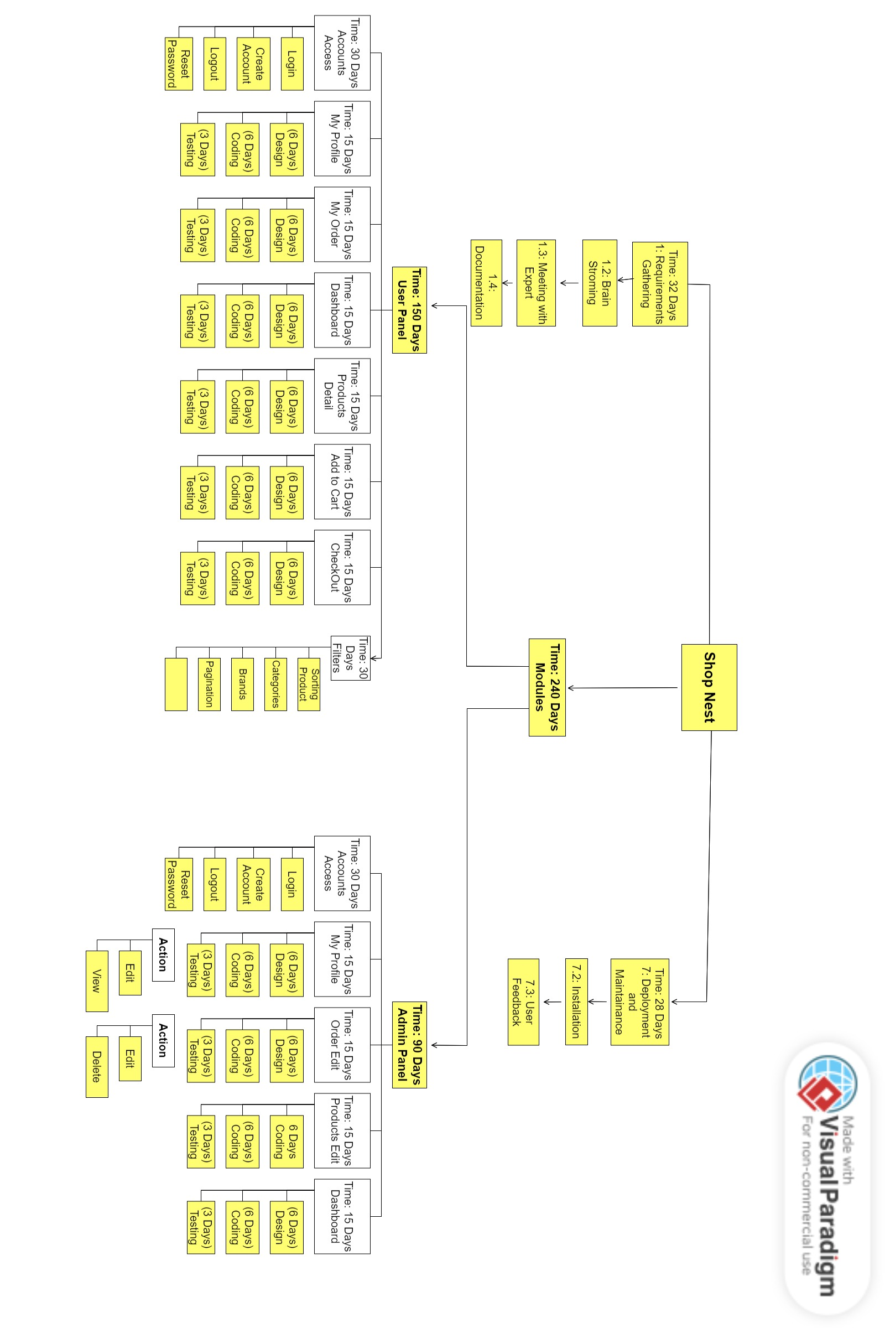
Fig 1.7.1 Work break-down Structure

Gantt Chart
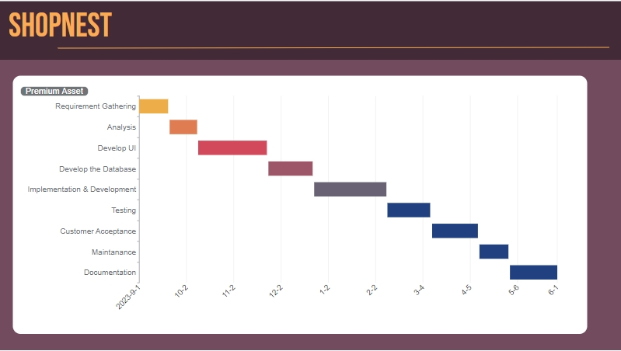

Fig 1.7.3 Gantt Chart

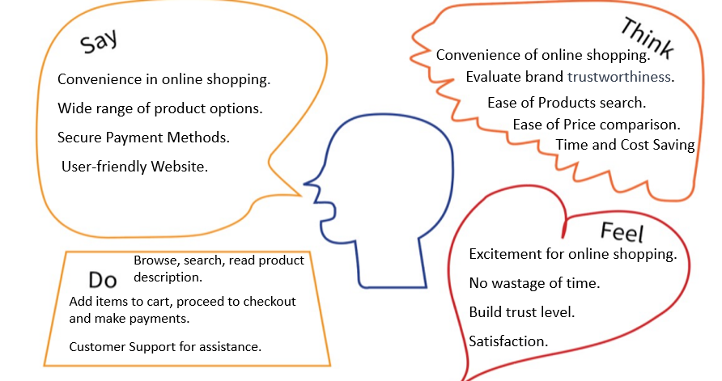Empathy Map

Fig 1.9 Empathy Map

Report Outline
- We have spent about 50 days in project requirements.
- We are making documentation, and it is in progress.
- We need more than 3 months for the coding and data were implanted.
- Error will be found and solve during coding and after testing and maintenance.
- Validation, finalization in added golden days.

Chapter 2

Software Requirement Specifications

Chapter 2: Software Requirement Specifications

Introduction

Goals
Purposes of our system are described underneath:
- Easy to preserve & alter all forms of Products and Order Details.
- It will produce a receipt and show it on the screen.
- We can also provide the power of home delivery.
- To keep all of the facts within the same database as a consequence, smooth to retrieve when required.

Reading Suggestions and Target Audience
Audience:
Partners: Business Owners, Business Managers, Project Manager.
Technical Team: Web Developers, Professionals of IT.
Marketing Team: SEO Specialist, digital marketers.
Academic: Faculty Members, Supervisors and project evaluators.
Reading Suggestions:
To have a quick review of our documentation, you should start with the executive summary, which provides a very concise review of our project. Business background tells you about the journey and the motivations behind bringing this project to life. Our group is focusing on specifications and providing more extra features to customers for their convenience.

Documentation Standards
- We will use the different heading levels to well organize the document.
- We will use a readable font and size of font throughout the whole document.
- We will use the same font size for all sections and for headings.
- We will bold our headings and subheadings.
- We will apply a uniform margin to all pages of the document.
- We will include the page number of the document in the header or footer.
- We will use the same line spacing throughout the document.
- We will use bullet points for non-specific order.
- We will use numbered lists for specific order.
- We will use labels and captions for images.
- We will include the list of references in a document.

References
We have not concerned any other sources.

Scope of Product
- Admin has the authority to engage the complete machine.
- Admin is allowed to maintain the information of employees.
- Admin is accountable to maintain the information of available inventory.
- Admin is responsible to deal with order setting and cancelling.
- Admin can view the everyday sale report.
- Admin can view each day order delivery document.
- It is an online machine.

Comprehensive Overview

User Classes and Characteristics
Admin:
Admin has the overall get right of entry to to the device which means he is capable of manage any activity with regard to the machine. He is the best privileged person who can get admission to to the device.

User:
User Class have precise system characteristic consistent with their want because of this they're able to Features regarding to the system. They have privileged according to their role.

Product Perspective
All pleasant, portions and quantity of our merchandise relying upon their class can be stored inside the catalog. Customer will come in our “Store” and makes an order about the product he/she desires.

Operations
Admin:
Login: for the reason of dealing with system.
View: for the purpose of checking the complete device.
Modify: for the motive of any desired change inside the modern-day system.
Logout: for logging out from the gadget.

User:
Login: for the purpose of appearing sports that he/she is allowed or has the authority.
Operation: he/she has the authority to view products, upload merchandise in the cart and take a look at out your everlasting cope with where you receive order
Operation: he/she has the authority to done charge by way of cash/card.
Logout: the User should logout after performing his/her activities.
Site adaption necessities:
This application will only have interaction with MongoDB database control device

Presumptions and Interdependencies
- First supposition is that it's miles a Website Application.
- Does not require any extra installation.
- Application is included with MongoDB database.
- System is based on MERN Stack Development.

System Requirements
System needs to be like minded and will easily run on window 7,8 ,10 to Latest model

Implementation and Design Boundaries
- GUI should be in undeniable English.
- Admin need to provide his/her ID to login to the gadget
- User must provide his/her ID to login to the device
- System should offer an option to logout from the device.
- Admin has the authority to trade patron’s order.
- Admin has the authority to maintain and adjust all information which include Products.

External Interaction Specifications

Communication Channels
Customer will interact through Admin with Email Messages.

User Interactions
- As defined above the precept web page will hold all data associated with all of the available products and as we hit the good enough button a pop-up message will seem on display.
- As the Admin and User confirm their authentication and hit the login button, they will be directed to the primary web page and login web page will fade away.
- When the Admin and User hits the logout button, all of the presently opened pages must be closed and login internet page have to appear.

Hardware Interactions
In this system printer can be used to print receipt.

Software Interactions
For services like Database system we shall use MongoDB latest version.

Functions of System
- Login
- Manage Products
- Manage Orders

Function 1
- Login

Priority and Details
This will Displayed a Login form to login user require her/her user name and password.

Priority: high

Action/Outcome Steps
Stimulus: Admin/User Run the application.
- Response: Login page is displayed.
- Stimulus: Admin/User Enter User Name and Password in login form.
- Response: Validate User Name and Password from database.
- Stimulus: Admin/User press Login Button.
- Response: Home page is displayed if user name and password is correct
else invalid Error message shown

Operational Requirements

REQ-SF2-1: Authenticate the consumer nicely to keep away from unauthorized get right of entry to to the system.
REQ-SF2-2: Lock the machine after ten wrong attempts and display the message to contact to system administrator.
REQ-SF2-3: Show the message on a success login.

Function 2
- Manage Products

Priority and Details
Only Admin performs CRUD operation on the Products data.
Priority: medium

Action/Outcome Steps
Stimulus: Click on Manage Products from menu list.
Response: Show the listing of Add Products.
Stimulus: Click on CRUD operation on Products.
Response: Shows result consistent with command.
Stimulus: Click on save button.
Response: Store the Products information in database.

Operational Requirements
REQ-1: Admin will be able to carry out CRUD operation on Products.
REQ-2: Store information of Products into database.

Function 3 (and so on)
- Manage Orders

Priority and Details
Admin can perform CRUD operation on Orders data.
Priority: medium

Action/Response Steps
Stimulus: Click on Manage Orders from menu list.
Response: Show the listing of View Orders.
Stimulus: Click on CRUD operation on Orders.
Response: Shows end result in keeping with command.
Stimulus: Click on shop button.
Response: Store the Orders details in database.

Operational Requirements
REQ-1: The Admin shall be able to carry out CRUD operation on Orders.
REQ-2: Store info of Orders into database.

System Constraints

System Performance Matrices
The software program first-class attributes are given below:

Adaptability:

There can be a alternate in data stored inside the database about Customers and stock. [1]

Availability:

The machine is up and jogging for maximum of the time and server ought to no longer down to
keep away from inconvenience of the customers.

Correctness:

The bill generated by way of the utility should be accurate.

Flexibility:

If need arises in the destiny, Website may be modified to change the necessities.

Maintainability:

Software may be without problems repaired if a fault takes place.

Reusability:

Current model may be used inside the destiny versions with extra functionality delivered.

Usability:

Interface of the Website is simple to apply, so interface have to be easy.

Citeria of Performance
The machine has to be interactive, and the delays involved are very less in every movement-response of the machine, in case of Searching Products via the database there need to be a put off of no extra than 1 2d. Also Delete/ updates includes little or no delay. And connecting to the database server the delay to make a hit connection ought to be less for effective actual time conversation.

Citeria of Safety
The Website is completely environmentally friendly and does now not cause any
protection violations.

Citeria of Security
Login ought to be required to get entry to the machine which stops unauthorized access. Information transmission must be securely transmitted to DB with none changes in Information to keep away from disturbances in orders and billing.

5.4.1 Adaptability:
There can be a change in information stored in the database about Employees
and inventor

Additional Specifications
System should be run on any Platform so that all the Task of the machine may be completed effortlessly.

Chapter 3

Use Case Analysis

Chapter 3: Use Case Diagram
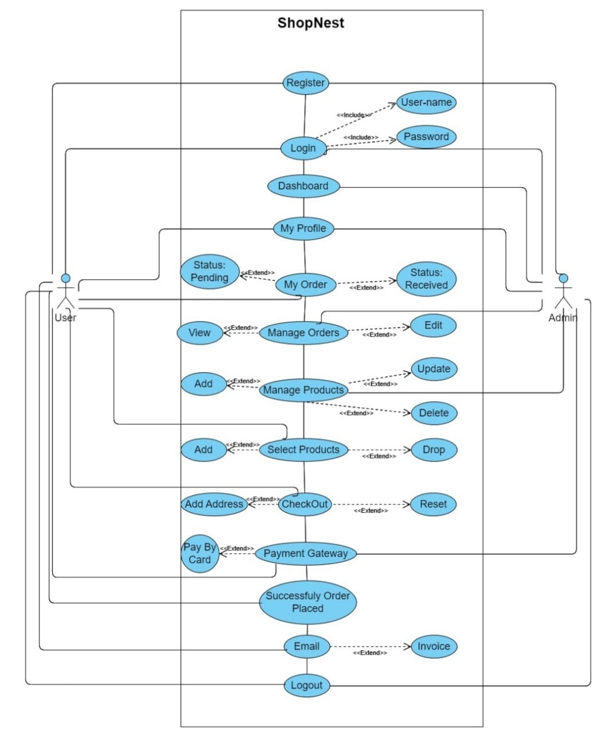Fig 3 Use Case Diagram
Description:

In figure 3, there are two actors in the project, one is “User” and the other is “Admin”. The first use case is “Register” where both the actors “User and Admin” can register. The second use case is “Login” where both the actors “User and Admin” can login in the system. The third use case is “Dashboard” where user can see the dashboard of the project. The fourth use case is “My Profile” where both the actors “Admin and User” can manage their profile. [1]

The Fifth use case is “My Order” which only be accessed by one actor “User” because he can place order. The sixth use case is “Manage Orders” and the only one actor which is “Admin” can manage all the orders which is placed by the customers. The seventh use case is “Manage Products” and this is also managed by one actor “Admin”. The eight-use case is “Select Product” which can be selected by one actor “User”, The ninth use case is “Checkout” and the only user can perform this action by entering his shipping information.

The tenth use case is “Payment” where the only one actor “User” can make the payment online by entering his card information. The next use case is “Order Placed” which can also be done by “User”. The next use case is “Email” and this is also received by only “User”. The last use case is “Logout” where both the actors “User and Admin” can logout from the system.

Fully Dressed Use Cases
Fig 3.1 Fully Dressed Use Cases

- Register:

Use case name | Register account
Primary actor | Customer
Secondary actor | Admin
Stakeholders | OS providers, Customer, Admin, Network providers, developers
Post conditions | Register account
Pre-conditions | System must be installed
Success path | - Enter Full Name  - Enter Address  - Enter valid Email  - Enter Gender  - Enter password  - Press Register button  - Successfully Register Account
Non-functional requirements | Security,  Performance

- LOGIN:

Use case name | Login account
Primary actor | Customer
Secondary actor | Admin
Stakeholders | OS providers, Customer, Admin, Network providers, developers
Post conditions | Login account
Pre-conditions | Register account
Success path | - Enter valid email  - Enter password  - Press login button  - Successfully login
Non-functional requirements | Security,  Performance

- My Profile:

Use case name | My Profile
Primary actor | Customer
Secondary actor | Admin
Stakeholders | OS providers, Customer, Admin, Network providers, developers
Post conditions | My Profile
Pre-conditions | Login Account
Success path | - Edit Full Name  - Edit Profile Image  - Edit Address  - Edit valid Email  - Edit Gender  - Edit password  - Press Save Changes button  - Successfully Update My Profile
Non-functional requirements | Security,  Performance

- Manage Products:

Use case name | Manage Products
Primary actor | Customer
Secondary actor | Admin
Stakeholders | OS providers, Customer, Admin, Network providers, developers
Post conditions | Manage Products
Pre-conditions | Login
Success path | - Enter Product name  - Enter Product Price  - Enter Product quantity  - Enter Product image  - Enter Product Description  - Add Product  - Delete Product  - Update Product
Non-functional requirements | Security, Privacy  Performance

- Manage Order:

Use case name | Manage Order
Primary actor | Customer
Secondary actor | Admin
Stakeholders | OS providers, Customer, Admin, Network providers, developers
Post conditions | Manage Order
Pre-conditions | Login
Success path | - Enter Order Number  - Enter Product Item  - Enter Shipping Address  - Enter Payment Method  - Enter Total Amount  - Edit Order Status  - Delete Order  - Edit Payment Status
Non-functional requirements | Security, Privacy  Performance

- Checkout:

Use case name | My Profile
Primary actor | Customer
Secondary actor | Admin
Stakeholders | OS providers, Customer, Admin, Network providers, developers
Post conditions | My Profile
Pre-conditions | Login Account
Success path | - Enter Full Name  - Enter Phone Number  - Enter Street Address  - Edit valid Email address  - Edit City  - Edit Payment Method  - Press Add Address button  - Successfully Checkout
Non-functional requirements | Security,  Performance

- Payment Method:

Use case name | Payment Method
Primary actor | Customer
Secondary actor | Admin
Stakeholders | OS providers, Customer, Admin, Network providers, developers
Post conditions | Payment Method
Pre-conditions | Login account
Success path | - Enter Card Number  - Enter Expiration  - Enter CVC  - Enter Country  - Press Pay Now button  - Successfully Payment
Non-functional requirements | Security,  Performance

Chapter 4

System Design

Chapter 4: System Design

Domain Model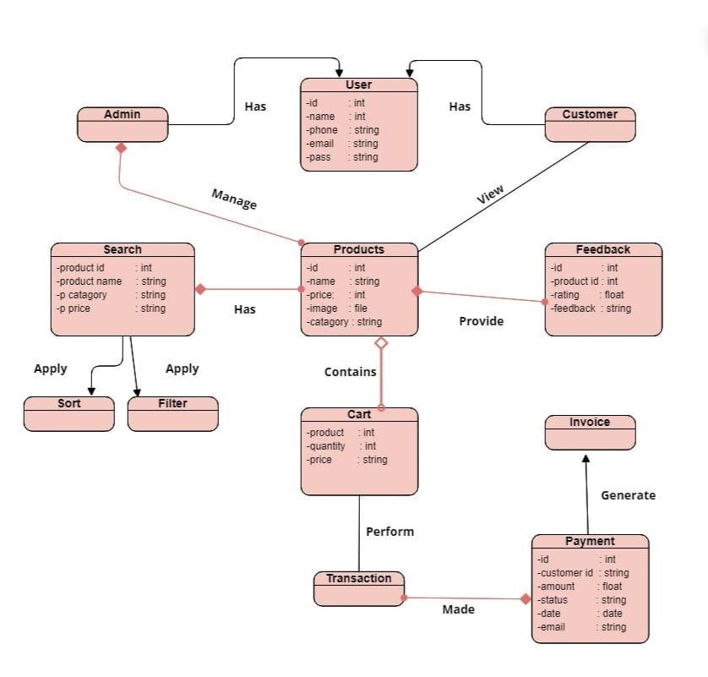

Fig 4.1 Domain Model Diagram

Entity Relationship Diagram
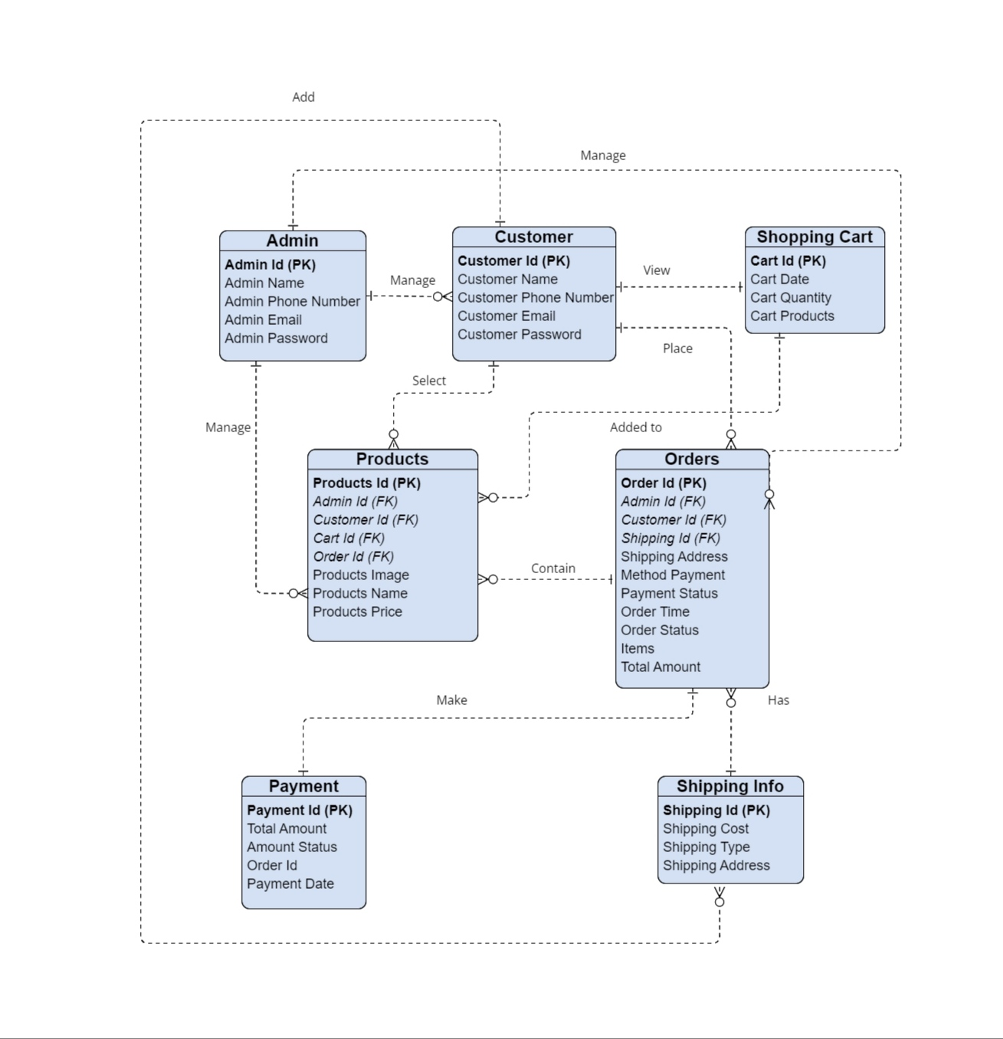

Fig 4.2 ERD Diagram

Class Diagram

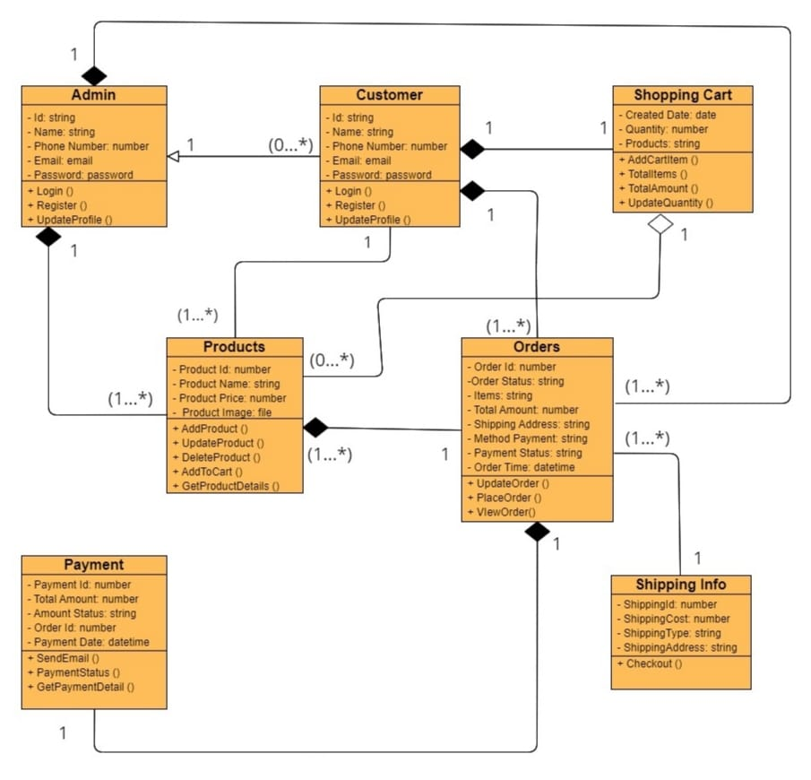
Fig 4.3 Class Diagram

Sequence Diagram
Authentication:

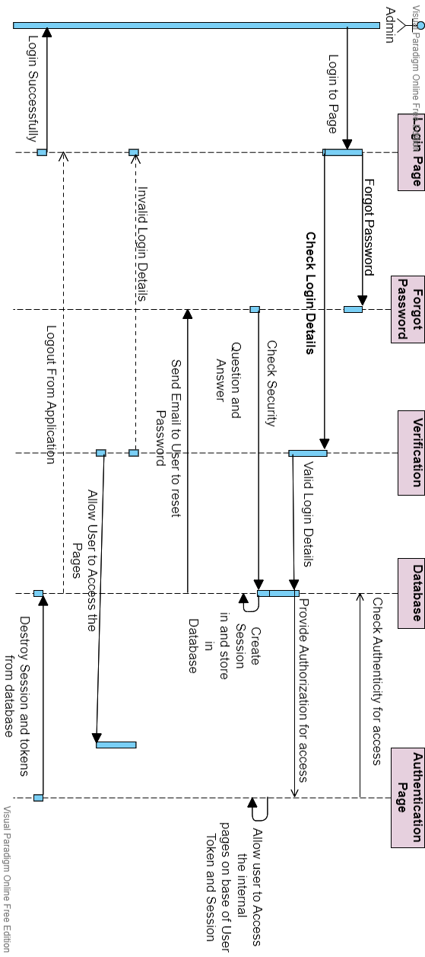
Fig 4.4.1 Admin Authentication Sequence Diagram

Search Products:

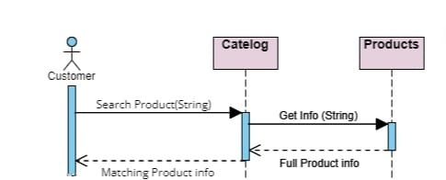
Fig 4.4.2 Search Product Sequence Diagram

Add Products to Card:
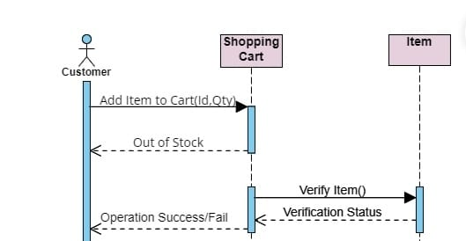
Fig 4.4.3 Add Products to Cart Sequence Diagram
Order Place:
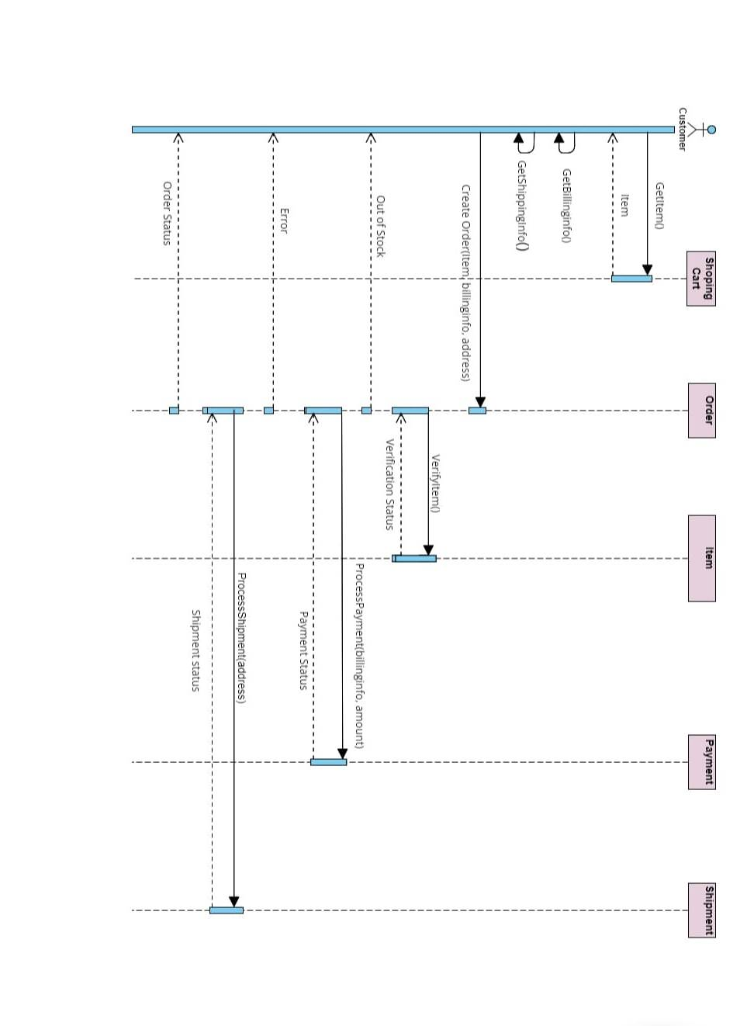
Fig 4.4.4 Order Place Sequence Diagram

Activity Diagram
Admin Side
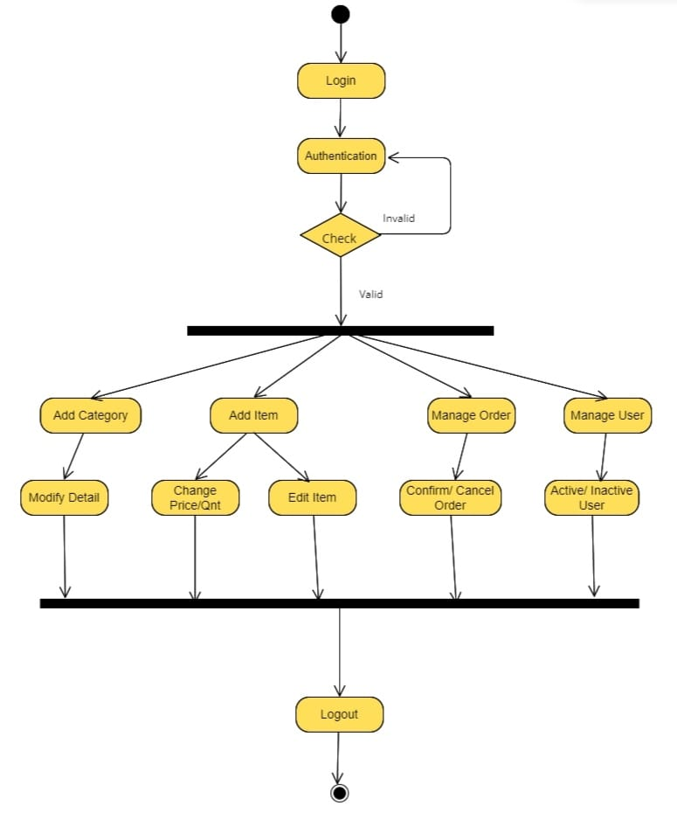

Fig 4.5.1 Admin Side Activity Diagram

User Side
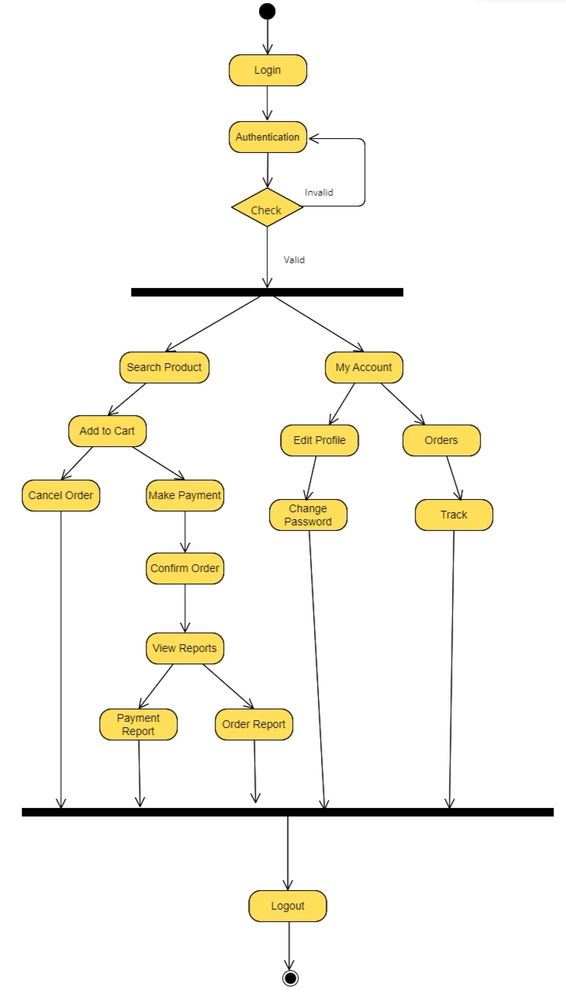

Fig 4.5.2 User Side Activity Diagram

State Transition Diagram

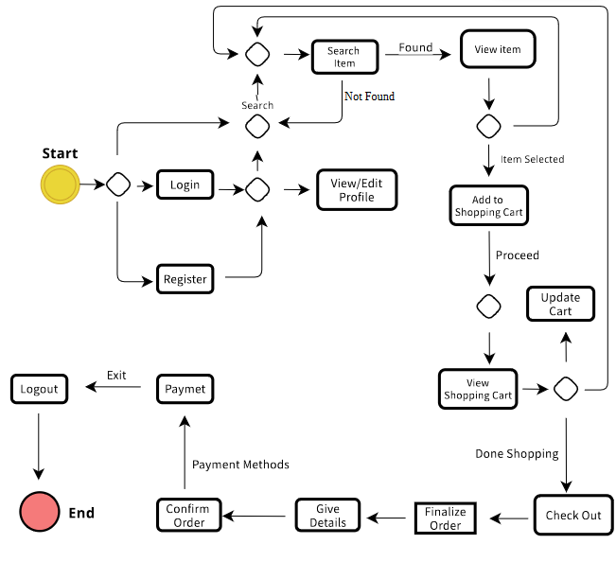
Fig 4.6 State Transition Diagram

Component Diagram
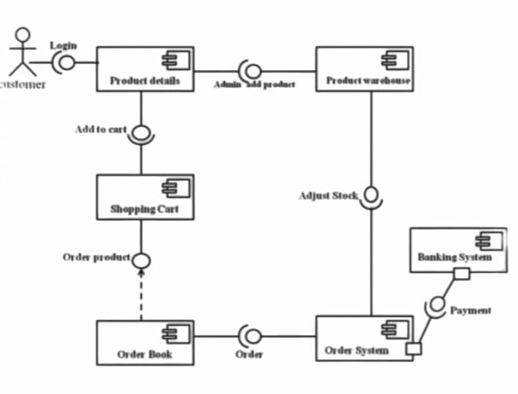
Fig 4.7 Component Diagram

Deployment Diagram
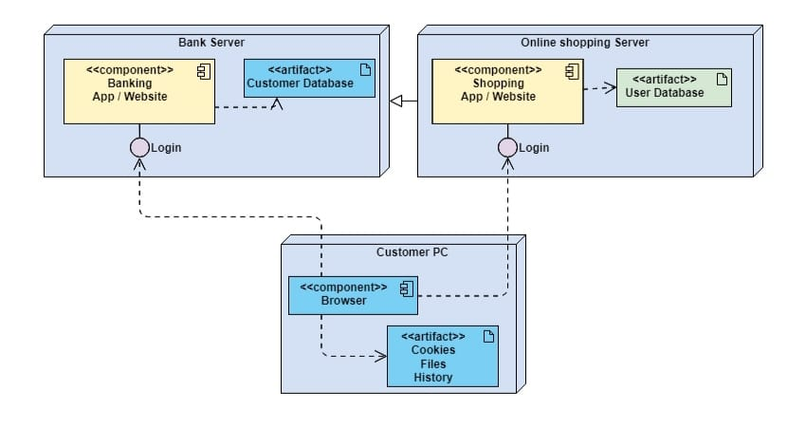
Fig 4.8 Deployment Diagram

Data Flow diagram
Admin Side
Level 0
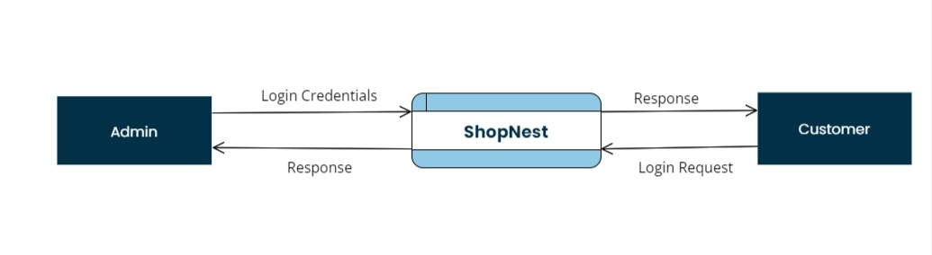
Fig 4.9.1.1 Level 0 Admin DFD

Level 1
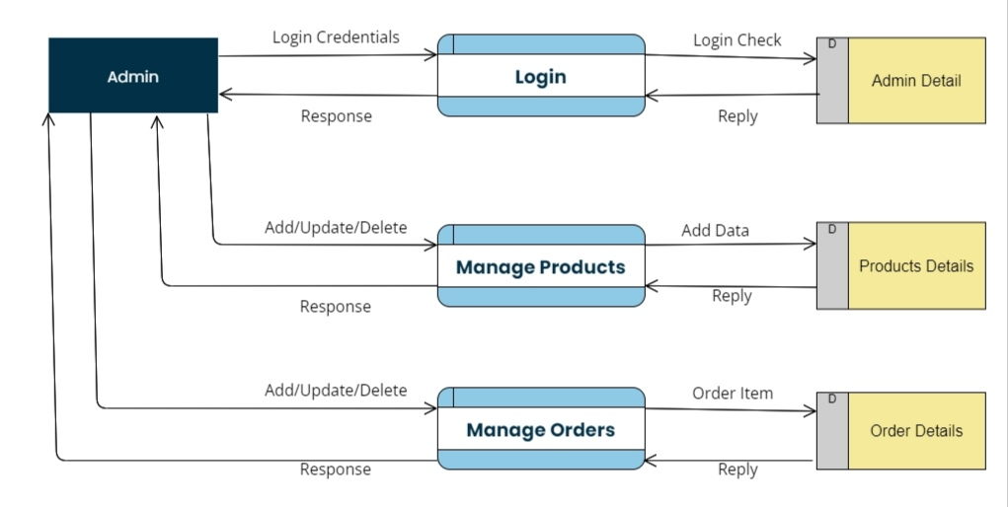
Fig 4.9.1.2 Level 1 Admin DFD

Level 2
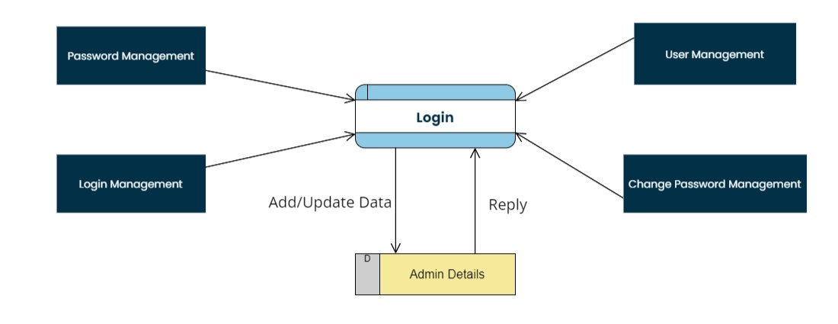
Fig 4.9.1.3 Level 2 Admin DFD

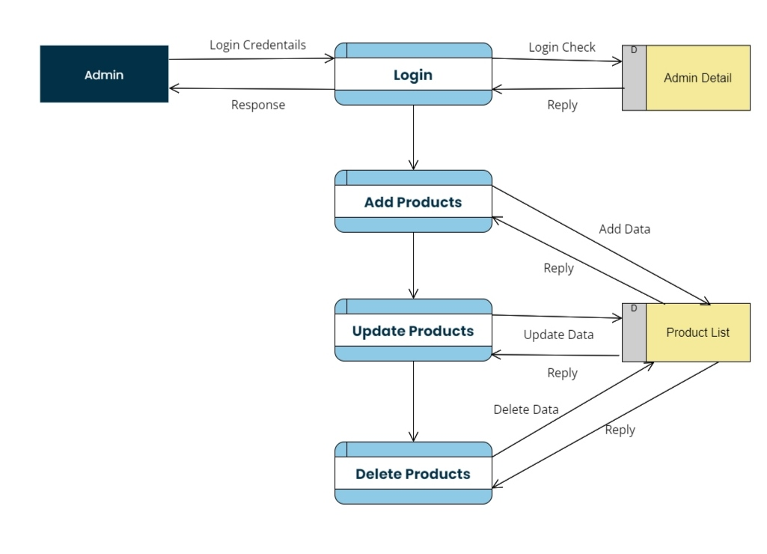
Fig 4.9.1.4 Level 2 Admin DFD
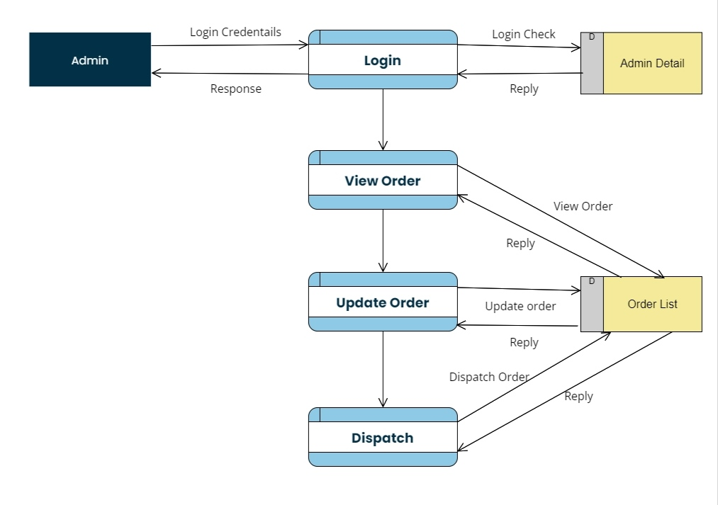
Fig 4.9.1.5 Level 2 Admin DFD

User Side
Level 0

Fig 4.9.2.1 Level 0 User DFD

Level 1
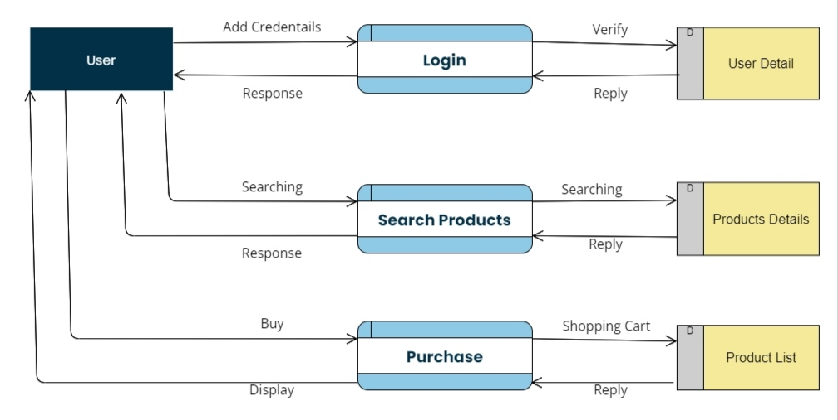
Fig 4.9.2.2 Level 1 User DFD

Level 2
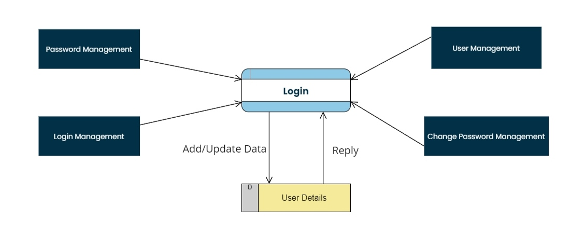
Fig 4.9.2.3 Level 2 User DFD

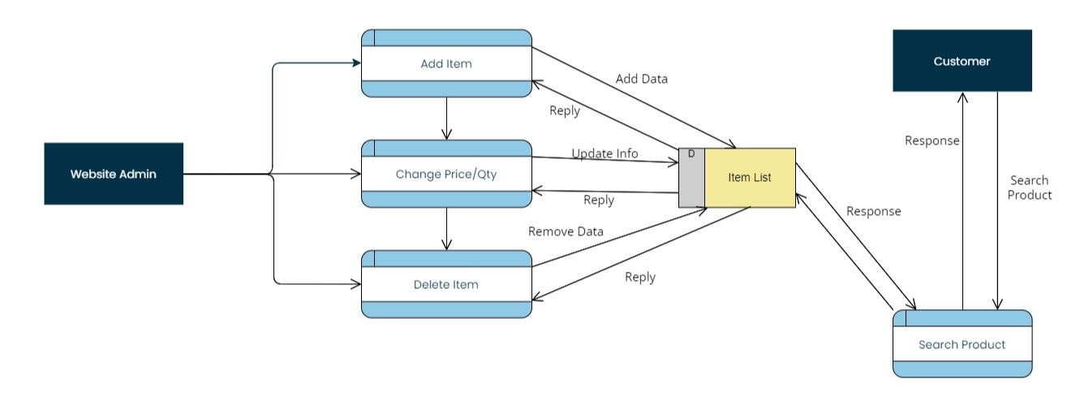
Fig 4.9.2.4 Level 2 User DFD

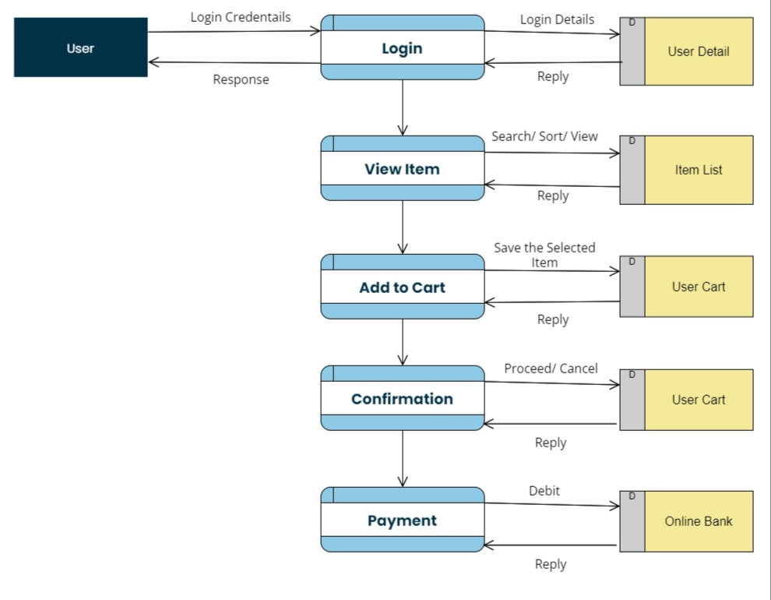
Fig 4.9.2.5 Level 2 User DFD

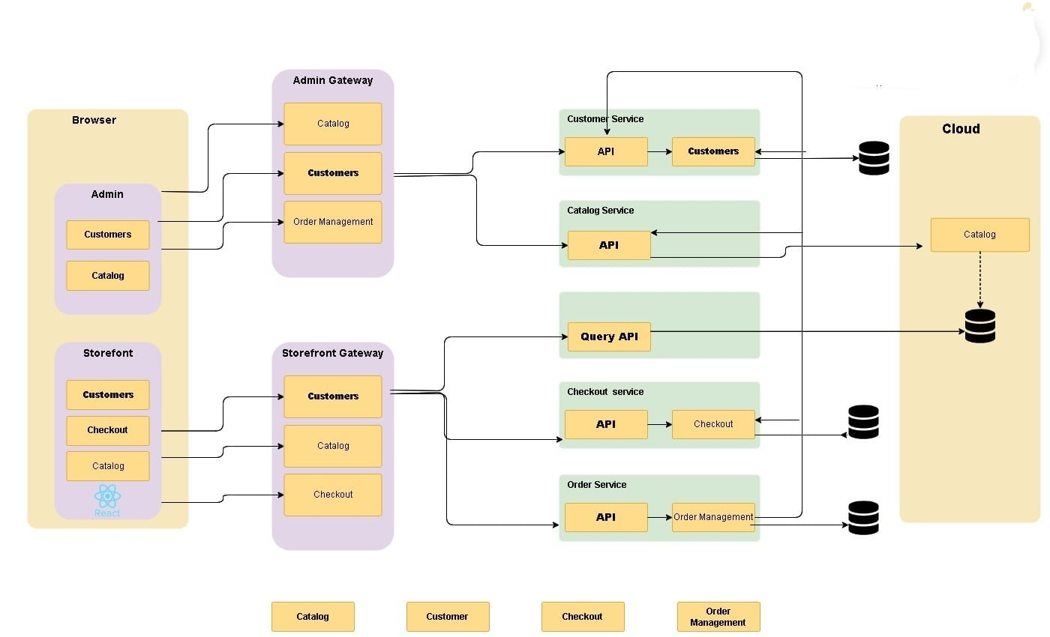
Architecture Diagram

Fig 4.10 Architecture Diagram

Chapter 5

Implementation

5.1 Components, Libraries

5.1.1 Components
Navbar/Header Component
- Navigation bar with links to product classes, consumer account, cart, and many others.
Product Listing Component
- Display grid or listing of merchandise with photos, names, charges, and alternatives.
Product Details Component
- Detailed view of a single product with additional information and alternatives.
Shopping Cart Component
- Display introduced items, portions, prices, and regulate/cast off alternatives.
Checkout Component
- Form for users to enter delivery information, fee statistics, and whole the acquisition.
User Authentication Components
- Login and registration paperwork, consumer profile control, password reset.
Error and Success Components
- Display mistakes messages, achievement notifications, or signals for various actions.
Footer Component
- Footer segment with hyperlinks to policies, contact records, and location navigation.

5.1.2 Libraries
- Redux Toolkit with Async Thunk
- Authentication via Passport JS
- REST API Auth via Passport JWT
- Email via Node mailer (Gmail)
- Mongoose Models
- Model-View-Controller on Backend

5.2 Operational Environment
- Deployed website in Vercel with Mongo Atlas Database Server

5.3 Development and Resources
Frontend Development
- React
- Redux Toolkit (State control and Async Thunk)
- React Router
Backend Development
- Node.JS
- Express.Js
- Passport.Js (Authentication)
- MongoDB with Mongoose (Database)
Additional Integrations
- Stripe API (Payment processing)
- Node mailer (Email communication)
Development Tools
- Visual Studio Code (VSCode)
- Git & GitHub (Version manipulate)
- Postman (API testing)
Testing
- Jest & React Testing Library (Unit checking out)

5.4 Code Conventions
Naming Conventions
- Use camelCase for variables and function names.
- Use PascalCase for class and constructor names.
- Descriptive and meaningful names for variables, functions, and training.

Indentation and Formatting
- Use 2 or four spaces for indentation.
- Consistent placement of curly braces.
Comments and Documentation
- Descriptive feedback for complex common sense.
- Document characteristic parameters, return sorts, and purpose.
Error Handling
- Implement right error handling with significant messages.
- Use attempt-capture blocks for managing exceptions.
ESLint and Prettier
- Configure ESLint for code consistency.
- Use Prettier for code formatting.

5.5 Version Control
After the next release some new more sophisticated feature will be added and current bugs will be fixed.

Chapter 6

Evaluation and Testing

Chapter 6: Evaluation and Testing

User Experience Testing
Fig 6.1 User Experience Testing
- Login Test Case:
Scenario ID | 1
Scenario Description | Login
Test case ID | 1
Test Engineer | Usama
Dated | 20-10-2022
Pre condition | System must be installed, must registered
Test Data | User Email and Password
Step Execution | - Enter Email  - Enter Password  - Click Login Button
Expected Result | User Login
Actual Result | User Login
Status | Pass

- Admin/User Registration Test Case:
Scenario ID | 2
Scenario Description | Admin Registration
Test case ID | 2
Test Engineer | Usama
Dated | 20-10-2022
Pre Conditions | System must installed
Step Execution | - Enter ID  - Enter First Name  - Enter Last Name  - Enter Phone Number  - Enter Username  - Enter Password
Expected Result | Admin Register
Actual Result | Admin Register
Status | Pass

- Manage Products Test Case:
Scenario ID | 3
Scenario Description | Manage Products
Test case ID | 3
Test Engineer | Usama
Dated | 20-10-2022
Pre-Conditions | Login, Account Maintain
Step Execution | - Enter Product ID  - Enter Product Name  - Enter Product Price  - Enter Product Quantity  - Enter Product Image  - Enter Product Description  - Click Add Product Button  - Update Button  - Delete Button
Expected Result | Product Manage Successfully
Actual Result | Product Manage Successfully
Status | Pass

- Edit Order Test Case:
Scenario ID | 4
Scenario Description | Edit Order
Test case ID | 4
Test Engineer | Usama
Dated | 20-10-2022
Pre-Conditions | Login, Account Maintain, Product Inventory
Step Execution | - Edit Order NO  - Edit Items  - Edit Total Amount  - Edit Shipping Order  - Edit Order Status  - Edit Payment Method  - Edit Payment Status  - Click Edit Order Button  - View Order Button  - Delete Button
Expected Result | Order Edit Successfully
Actual Result | Order Edit Successfully
Status | Pass

- Checkout Test Case:
Scenario ID | 5
Scenario Description | Checkout
Test case ID | 5
Test Engineer | Usama
Dated | 25-12-2023
Pre-Conditions | Login, Account Maintain, Product Inventory, Manage order
Step Execution | - Enter Full Name  - Enter Phone Number  - Enter Street Address  - Edit valid Email address  - Edit City  - Edit Payment Method  - Press Add Address button
Expected Result | Checkout Successfully
Actual Result | Checkout Successfully
Status | Pass

- Payment Method Test Case:
Scenario ID | 6
Scenario Description | Payment Method
Test case ID | 6
Test Engineer | Usama
Dated | 25-12-2023
Pre-Conditions | Login, Account Maintain, Product Inventory, Manage order, checkout
Step Execution | - Enter Card Number  - Enter Expiration  - Enter CVC  - Enter Country  - Press Pay Now button
Expected Result | Payment Method Successfully
Actual Result | Payment Method Successfully
Status | Pass

Stress Testing
- User Authentication:
- Test the system's ability to handle a large number of concurrent login requests.
- Simulate scenarios where users repeatedly attempt to log in with incorrect credentials to assess the system's resilience against potential brute-force attacks.
- Evaluate the response time of the authentication process under heavy load.
- Browse and Search:
- Generate a significant volume of search queries and browsing requests to assess the system's responsiveness.
- Measure the time taken to retrieve search results and load product pages under varying levels of concurrent user activity.
- Product Details:
- Stress the system by requesting product details for a large number of products simultaneously.
- Evaluate the performance of loading product images, descriptions, specifications, and reviews under heavy load conditions.
- Shopping Cart:
- Simulate scenarios where multiple users concurrently add items to their shopping carts.
- Test the scalability of the shopping cart functionality by increasing the number of concurrent users and assessing the system's ability to handle simultaneous transactions.
- Checkout:
- Assess the system's ability to process a high volume of checkout requests within a specified time frame.
- Test different payment methods (e.g., credit card, PayPal) under stress conditions to ensure seamless transaction processing.

- Order Tracking:
- Stress the order tracking system by querying the status of numerous orders simultaneously.
- Evaluate the system's response time in providing real-time updates on order status and shipment tracking information.
- Admin Panel:
- Test the performance of the admin panel under heavy administrative tasks such as managing products, orders, and payments.
- Assess the responsiveness of the admin interface when handling concurrent requests from multiple administrators.
- Manage Products, Orders, and Payments:
- Stress test the functionality related to managing products, orders, and payments by simulating a high volume of concurrent administrative actions.
- Evaluate the system's ability to handle simultaneous updates, deletions, and modifications to product listings, order details, and payment records.

Equivalence partitioning
- User Authentication:
- Equivalence Classes:
  - Valid Input Example:
    - User enters their correct email like “Usama@gmail.com” and password like “student123*”
  - Invalid Input Examples:
    - User enters an incorrect email like “abxnm”
    - User enters an incorrect password like “($-^&)”
    - User leaves the credentials blank. like “-------”
- Browse and Search:
- Equivalence Classes:
  - Valid Input Example:
    - User searches with relevant keywords like “Sandle shoes”
  - Invalid Input Examples:
    - User performs an empty search query like “---------”
    - User searches for irrelevant keywords like “banana.”
- Product Details:
- Equivalence Classes:
  - Valid Input Example:
    - User requests details for a specific product with a valid product ID like “K93671927B123”
  - Invalid Input Examples:
    - User enters a non-existent product ID
- Shopping Cart:
- Equivalence Classes:
  - Valid Input Example:
    - User adds a product to their cart like “Pair of shoes”
  - Invalid Input Examples:
    - User tries to add irrelevant item like “Out-of-stock Shoes”
    - User enters an invalid quantity like “negative value”.
- Checkout:
- Equivalence Classes:
  - Valid Input Example:
    - User enters valid shipping address like “House no 123 Sabzazar Lahore” and payment details like “Card Number: 4242-4242-8780-4242”
  - Invalid Input Examples:
    - User leaves required fields empty like “-------”
    - User provides incorrect payment information like “Card No:abc78*”
- Order Tracking:
- Equivalence Classes:
  - Valid Input Example:
    - User tracks their order using a valid order ID like “#6460008dc7ae400”
  - Invalid Input Examples:
    - User enters an invalid order ID like “[abc80]”
    - User queries a non-existent order like “hello”
- Admin Panel:
- Equivalence Classes:
  - Valid Input Example:
    - Admin logs in with correct credentials like “admin@gmail.com” and “admin123*”
  - Invalid Input Examples:
    - Admin enters incorrect admin credentials like “abxnm” and “($-^&)”.
    - Unauthorized access attempts by non-admin users.
- Manage Products:
- Equivalence Classes:
  - Valid Input Example:
    - Admin adds new Shoes with accurate details.
    - Adding, updating, deleting shoes information
  - Invalid Input Examples:
    - Admin provides shoes data in an incorrect format.
    - Admin misses required fields like “size, color missing”
- Manage Orders:
- Equivalence Classes:
  - Valid Input Example:
    - Admin processes an order and updates its status like
“order status: pending/dispatch”
  - Invalid Input Examples:
    - Admin uses an invalid order ID like “[abc80]”
    - Unauthorized actions on orders.

- Manage Payment:
  - Valid Input Example:
    - Admin handles payments and verifies transactions.
  - Invalid Input Examples:
    - Admin enters incorrect payment details.
- Invalid payment methods used.

Data flow testing
- User Authentication Module:
- Validate the flow of user credentials during login and registration processes.
- Verify the handling of authentication tokens and session data.
- Browse and Search Module:
- Ensure accurate retrieval and display of product information based on user search queries.
- Validate the flow of search parameters and filtering options.
- Product Details Module:
- Verify the correct retrieval and display of detailed product information.
- Validate the flow of product attributes, such as size, color, and availability.
- Shopping Cart Module:
- Validate the addition, removal, and modification of items in the shopping cart.
- Verify the calculation of subtotal, taxes, and shipping costs.
- Checkout Module:
- Ensure the smooth flow of user data during the checkout process, including shipping address, payment information, and order summary.
- Validate the integration with payment gateways and the processing of transactions.

- Order Tracking Module:
- Verify the accurate display of order status and tracking information.
- Validate the flow of updates from order placement to delivery.
- Admin Panel Module:
- Ensure secure access to administrative functionalities.
- Validate the flow of data related to user management, product management, and order management.
- Manage Products Module:
- Verify the smooth flow of product data updates, including addition, deletion, and modification.
- Validate the synchronization of product information across the application.
- Manage Orders Module:
- Validate the flow of order data, including order status updates and order processing.
- Ensure accurate retrieval and display of order details for administrative purposes.
- Manage Payment Module:
- Verify the secure handling of payment information, including encryption and transmission protocols.
- Validate the integration with payment gateways and financial institutions.

Boundary value analysis

- User Authentication:
  - Boundary Values:
    - Minimum valid username length: 1 character
    - Maximum valid username length: 50 characters
    - Minimum valid password length: 7 characters
    - Maximum valid password length: 20 characters
- Browse and Search:
- Boundary Values:
      - Minimum number of search results displayed per page: 1
      - Maximum number of search results displayed per page: 10
      - Minimum and maximum price range for filtering search results
- Product Details:
    - Boundary Values:
      - Maximum product description length: 1000 characters
      - One item is added to cart only once.
- Shopping Cart:
    - Boundary Values:
      - Minimum number of products that can be added to the cart is 1.
      - Maximum number of products that can be added to the cart are the total number of products available.
- Checkout:
    - Boundary Values:
      - Minimum quantity of products that can be purchased in a single transaction is 1.
      - Maximum quantity of products that can be purchased in a single transaction are the total number of stocks available.
- Admin Panel:
- Boundary Values:
  - Minimum number of products/orders displayed per page in the admin panel is 1.
  - Maximum number of products/orders displayed per page in the admin panel is 10.
  - Minimum number of admin users allowed is 1.

- Manage Products:
  - Boundary Values:
    - Minimum product name length is 5 characters.
    - Maximum product name length is 100 characters.
    - Minimum product price is 10$.
- Manage Orders:
- Boundary Values:
  - Minimum order quantity is 1.
  - Maximum order quantity is the total number of orders.

Unit testing
- User Authentication:
- This module deals with user login, registration, password reset, and authentication processes. Unit tests will ensure that users can successfully register, login with valid credentials, fail to login with invalid credentials, and reset their passwords securely.

- Browse and Search:
- This module enables users to browse through the catalog of fancy ladies’ shoes and search for specific products based on various criteria. The testing of this module validates that the user will easily browse pages and products. The user can also search the products with voice commands and can filter products easily.

- Product Details:
- The testing of this module validates that the information of product can be easily fetched from the database and shows to customers. The information should be correct and related to the product.

- Shopping Cart:
- The testing of this module validates that the user will be able to add products in cart successfully. User will be able to update the quantity of product items, delete any product from cart. The Cart Page also calculates the total price of items.

- Checkout:
- The testing of this module validates that the user can successfully update the quantity of products, add the new shipping address or select from the existing addresses. The user will be able to pay amount successfully or select the cash option to place the order successfully. The payment information should be secure and private.

- Order Tracking:
- The testing of this module validates that the user can easily get the information of their orders. The users can check the status of their orders whether it is delivered, dispatched or pending.

- Admin Panel:
- The testing of this module validates that the user is customer or admin. If the user is admin, then the options like Cart, my orders will not be accessible because these are the options of customers. The admin can add/edit and delete products, can check the orders and update the information of orders.

- Manage Products:
- The testing of this module validates that the user must be admin. The admin can easily update the information of products, add new product in the product list and delete any product.

- Manage Orders:
- The testing of this module validates that the user must be admin. The admin can easily update the information of orders like dispatched, delivered, pending. The admin can also cancel the order in any case. Admin can check all orders.
- Manage Payment:
- The testing of this module validates that the user can easily pay the amount of order. The payment information must be secure and private. In case of any network issue the system will be able to handle any kind of situation and payment status.

Performance testing
- User Authentication:
- This testing includes the response time of authentication. When user login or signup, the response time must be lesser to enhance customer experience.
- If user can login or signup in website, how many times the user can successfully login with correct information. The success rate must be 100%.
- Also evaluate this module when the traffic is too high, check that website will be responsive or not.
- Browse and Search:
- The testing of this module validates the responsiveness of website with heavy traffic or heavy load.
- The products must be fetched faster and takes less time to display its information in a page for best customer experience.
- The user can easily search products and the response time must be lesser. The success rate must be 100%.

- Product Details:
- The testing of this module checks the speed and response of the information fetched. The response time must be lesser.
- The details fetched from the database should be related and correct. The success rate must be 100%.
- When the traffic is high check the speed and responsiveness of page. The page is responsive or not.
- Shopping Cart:
- The testing of this module checks the speed and response of the information fetched. The response time must be lesser.
- The page will be able to fetch all items that the user has added in the cart. User can easily update the quantity within no time.
- User will be able to easily navigate to the checkout page. Check the responsiveness of page when the traffic is high.
- Checkout:
- The testing of this module can check the speed and response time of the page. The response time should be lesser to provide customer satisfaction.
- It also checks the reliability of the payments system. The success rate should be 100%. The user can easily pay the number of orders.
- When traffic is high check that the user can easily perform transaction or not. Also check the responsiveness of the page.
- Order Tracking:
- The testing of this module checks the speed and response of the information fetched. The response time must be lesser.
- The user can easily check the information of his orders only. The system will be able to provide correct order details to customers.
- Check the response time of page when traffic is high. The system will be able to provide information in any case.
- Admin Panel:
- When traffic is high check the performance of the page, it is responsive or not. System must be able to perform actions in any case.
- When the user is admin, the Cart page, My-Orders page must not be shown. The admin can see the Manage Products page and All Orders page.
- Check the reliability of website with both customer login and admin login. The success rate must be 100%.
- Manage Products, Orders, and Payments:
- The testing of this module checks that the admin will be able to perform different actions in a system like edit the information of any product, delete any product or add new product in a list.
- Check the response time of the website and also check the speed. The response time must be lesser to provide customer satisfaction.
- Check the performance of website when traffic is high.

Integration testing
- User Authentication Integration Testing:
- This testing includes the verification that the website will work fine when this module combines with other modules of the website like Products Page.
- Check different cases and access control after login, signup, or logout from the system. The system must be reliable after integration
- Browse and Search Integration Testing:
- This testing includes the verification that browsing and searching functionalities work smoothly with other modules.
- Check different cases like searching for products, filtering search results, and navigating from different pages.

- Product Details Integration Testing:
- This testing includes the verification that the website will work fine when this module combines with other modules of the website like Authentication.
- Check different cases like viewing product details, adding products to cart, and going back to Home Page.
- Shopping Cart Integration Testing:
- This testing includes the verification that the website will work fine when this module combines with other modules of the website like Products Detail Page.
- Check different cases like removing items from the cart, update quantities of products, and the total price of items.
- Checkout Integration Testing:
- This testing includes the verification that the website will work fine when this module combines with other modules of the website like Shopping cart.
- Check different cases like add new address, select from the existing addresses and pay amount successfully in case of online transaction.
- Order Tracking Integration Testing:
- This testing includes the verification that the website will work fine when this module combines with other modules of the website like Checkout and Authentication.
- Check different cases like check order status, payment status, and all of his previous orders.
- Admin Panel Integration Testing:
- This testing includes the verification that the website will work fine when this module combines with other modules of the website like Checkout and Authentication.
- Check different cases like add new products, edit any product, check all the orders and update the order status in case of delivered.
- Manage Products Integration Testing:
- This testing includes the verification that the website will work fine when this module combines with other modules of the website like Checkout and Authentication.
- Check different cases like add any product, update any product information, and delete any product from the list. The system must be reliable after integration.

- Manage Orders Integration Testing:
- This testing includes the verification that the website will work fine when this module combines with other modules of the website. The website must be reliable.
- Check different cases like view all orders, update any order status, and cancel an order from the list of orders.
- Manage Payment Integration Testing:
- This testing includes the verification that the website will work fine when this module combines with other modules of the website like Authentication and Manage Orders.
- Check different cases like process payments, handle refunds, and provide the reliability in payment.

Chapter 7

Conclusion, Summary and Future Enhancements

Chapter 7: Conclusion, Summary & Future Enhancements

Achievements and Improvements
Achievements:
- User Interface (UI) Design:
- Successfully Provide ease to the Customers to search through different shoe categories, filter options, and make purchases without any interruption.
- The User interface be visually user friendly, attractive and responsive across screen sizes and different devices can be done by successfully.
- Successfully Implement the working of checkout process without any interruption and provide appropriate functionality to customers to complete their purchases.
    - Login Page:
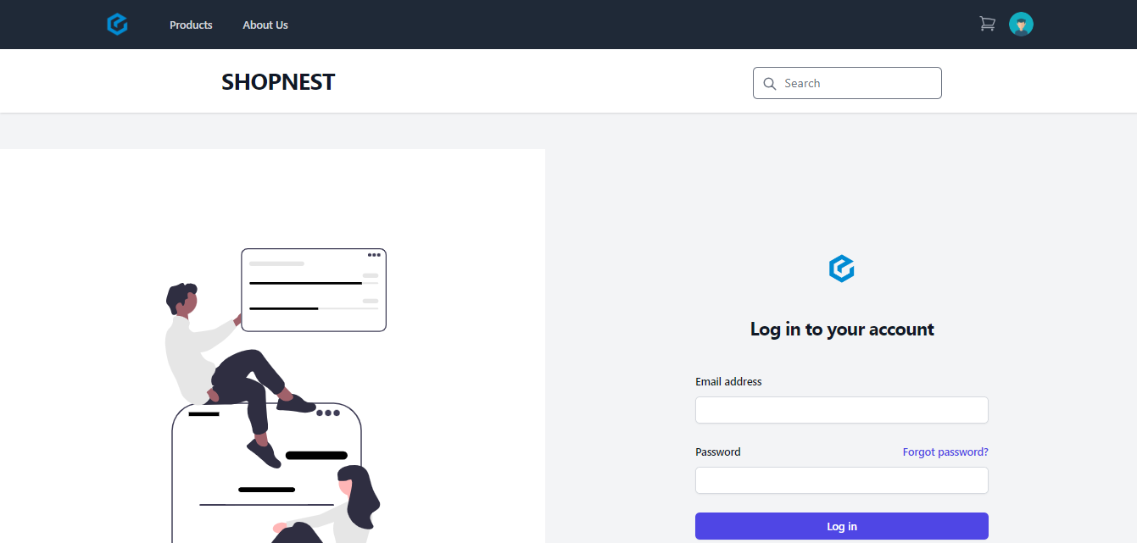
Fig 7.1.1 Login Page
    - Home Page
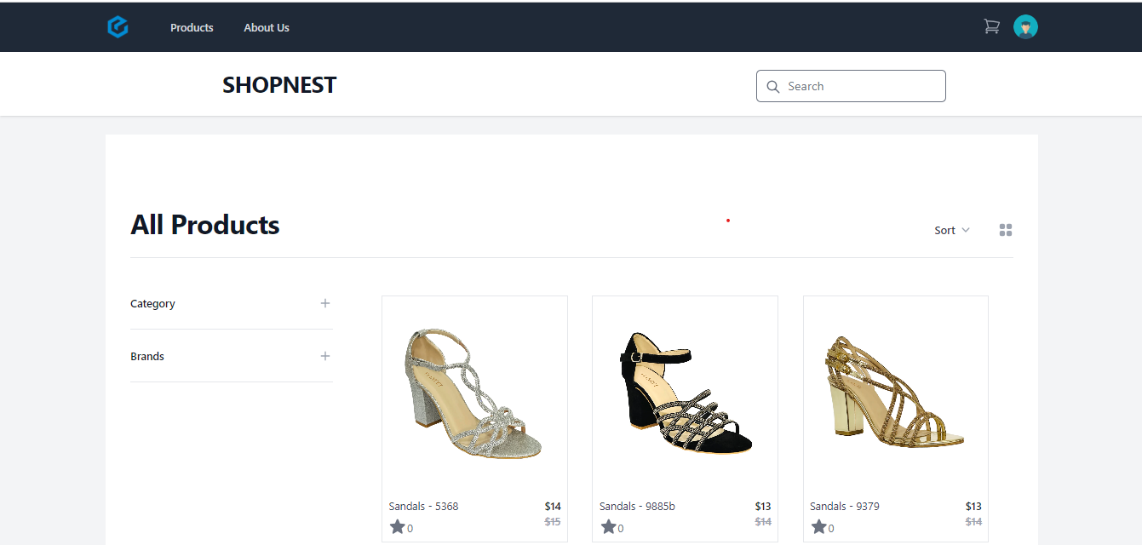
Fig 7.1.2 Home Page
    - Product Detail Page
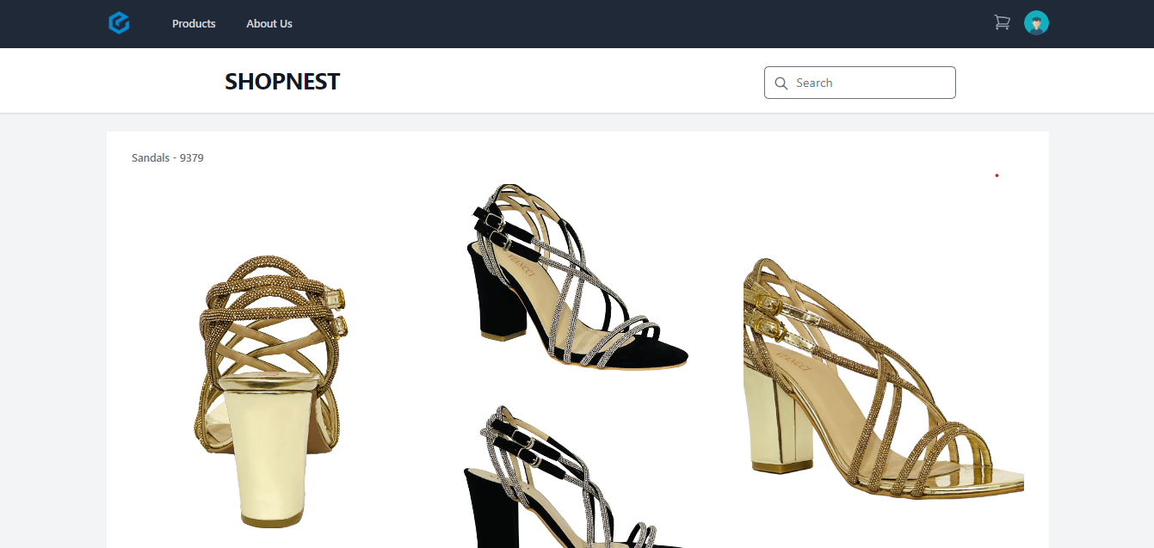
Fig 7.1.3 Products Detail Page
    - About Page
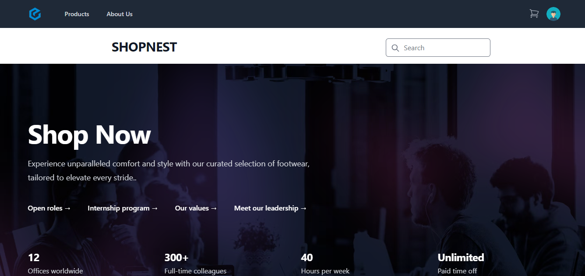
Fig 7.1.4 About Page
    - Cart Page
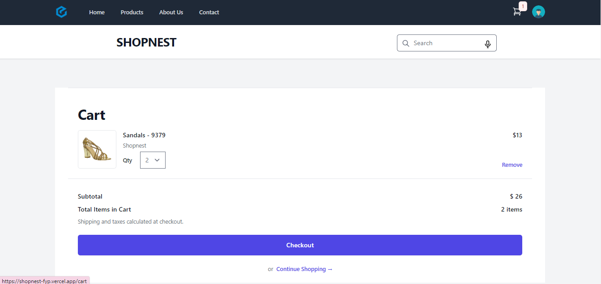
Fig 7.1.5 Cart Page
    - Checkout Page
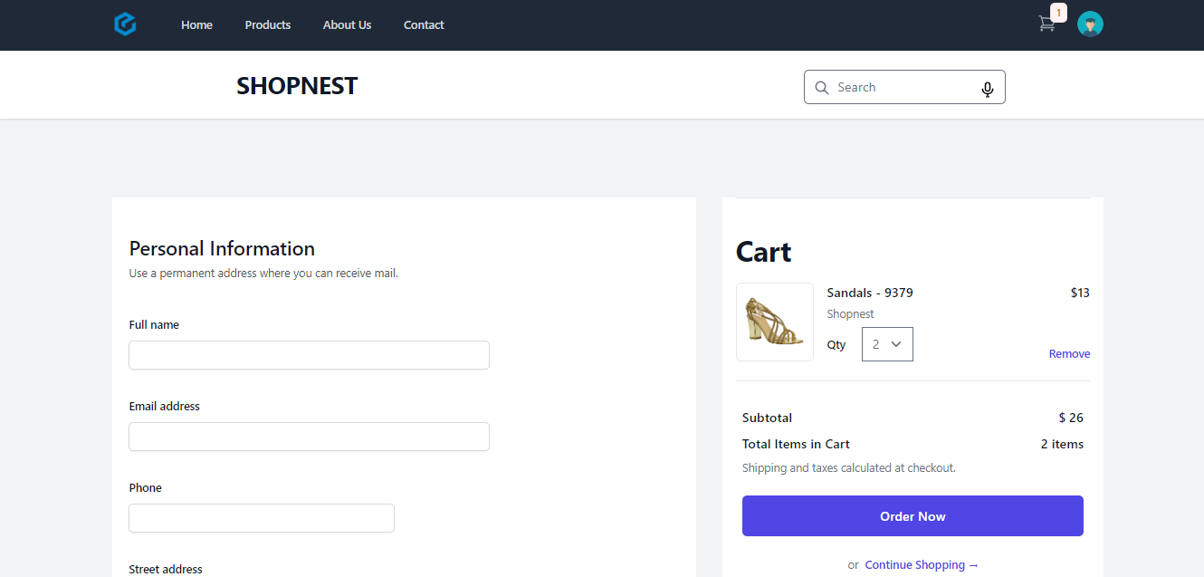
Fig 7.1.6 Checkout Page
    - Customer Orders Page
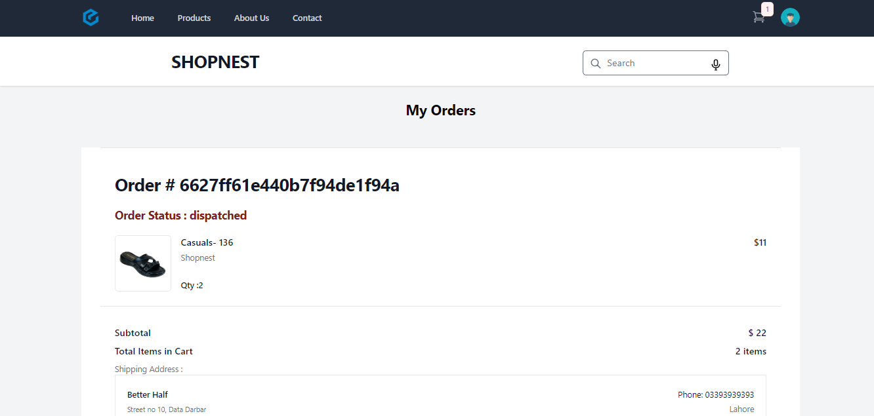
Fig 7.1.7 Customers Order Page
    - Admin Products Page
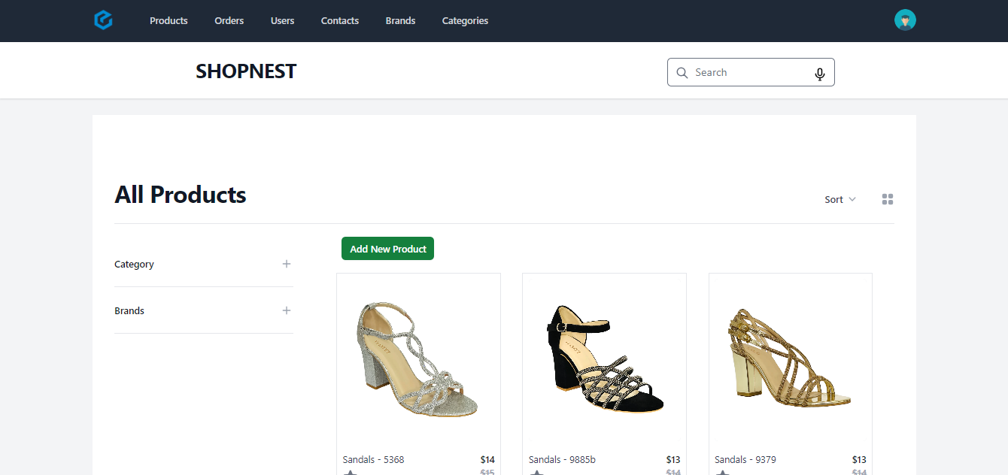
Fig 7.1.8 Admin Products Page
    - Admin Orders Page
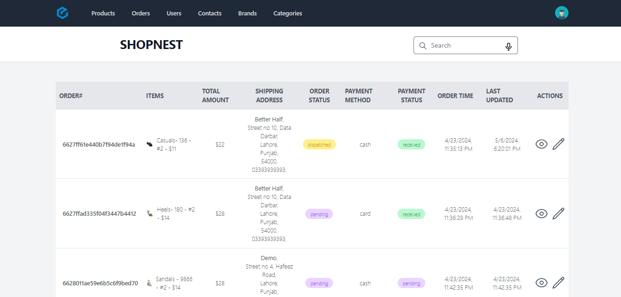
Fig 7.1.9 Admin Orders Page
- Product Variety and Quality:
- Successfully you have wide range of shoes varieties that can provide for different customers according to their preference and demographics
- Also built a partnership with different reputable shoes brands and suppliers to maintain high-quality standards of manufacturing of shoes and build trust among customers
- Search and Filter Functionality:
- Implement powerful search and filter options and allowing customers to quickly find specific styles of shoes with different sizes, colors, and brands.
- Also provide personalized recommendations technique by using machine learning algorithms which is based on customers browsing and purchasing history
- Payment and Security:
- Offer Customer secure payment gateways for transactions, providing various payment methods such as Jazz Cash, Easy Pasa, COD (Cash on Delivery)
- Implement strong security measures to protect customers' sensitive payment information and build trust in the platform.
- Customer Support:
- Customer support channels like (chat, email, phone number) are available to assist Customer with inquiries, concerns, or feedback.
- Common queries Addresses through FAQs Sections
- Inventory Management:
- Inventory management systems should be implemented by efficient way and make sure can be organized in accurate stock levels, improve order completion processes and prevent overselling.
- Also provide correct availability for each shoes style information to the customers.
Improvements:
- Enhanced Personalization:
- Personalization features need improve by some unique and advanced way engine which is based on Customers browsing history, Customers purchase patterns, and preferences
- Streamlined Checkout Process:
- Need some improvements in checkout process to reduce interruption and minimize idle carts, potentially by implementing guest checkout options and one-click purchasing features.
- Marketing and Promotion Strategies:
- Implement a strong marketing strategy to attract customers in which it can include, specific marketing promotions, Social media marketing and email marketing.
- Offer promotions, discounts, point system and membership rewards to attract customers that can repeat purchases
- Data Analytics and Insights:
- Implement strong data analytics tools to collect actionable insights into user behavior, sales trends, and market trends.
- Also Implement data-driven decision-making technique to optimize product offerings and pricing strategies for better business outcomes.
- Internationalization and Localization:
- By offering multiple languages and currencies you can expand the application reach by searching some opportunities to worldwide audience
- you can adapt latest techniques to improved marketing strategies and product offering that can echo in international markets with different cultural preferences and market dynamics.
By implementing these improvements while building upon the achievements of the SHOPNEST application, you can further enhance its success in the e-commerce footwear market.

Project Summary
Project Title: SHOPNEST
“Overview: SHOPNEST is an innovative e-commerce platform designed to cater to the diverse needs of shoe enthusiasts. It offers a wide variety of shoes sourced from different manufacturers and sellers, providing customers with a seamless shopping experience. The platform prioritizes user satisfaction through its intuitive interface, secure payment gateways, and efficient delivery services.”
Key Features:
- User Authentication:
- In ShopNest Application the User can login with their own Email and Password and It can also provide facility to create account
- It can also ensure the safety of User data by some secure protocol
- Browse and Search:
- In this Application the customer provide facility to search wide variety of shoes categorized based on its brand, size, color, price range.
- Customer can help to search specific product quickly by advanced search filters
- Product Details:
- In this application Product detailed page provide information such as Product Price, Product Description, Product Images, Sizes available, Material used.
- It can also provide the feature of high quality images that helps the user to see closer look at the shoes
- Shopping Cart and Checkout:
- Customer can add Products to their shopping cart for proceed directly to checkout or for later purchase.
- Customer helps secure payment gateways for transactions, providing various payment methods such as Jazz Cash, Easy Pasa, COD (Cash on Delivery)
- Order Tracking:
- In this application Customer can provide facility to track their order in real time, from processing to delivery.
- Notifications keep Customers informed about their order updates.
- Customer Support:
- Customer support channels like (chat, email, phone number) are available to assist Customer with inquiries, concerns, or feedback.
- Common queries Addresses through FAQs Sections
- Admin Panel:
- In this Application Admin have full control over the platform.
- It can Managing Customer accounts, product listings, payments, orders, and resolving disputes.
- Responsive Design:
- This application is optimized for various devices, including desktops, laptops, smartphones, and tablets, ensuring a Friendly user experience across platforms.

- Scalability and Performance:
- The Application is designed to handle high volumes of traffic and transactions,
- It ensuring reliability and performance during peak periods.
- Marketing and Promotions:
- In this Application we can Integrated marketing tools enable promotional campaigns, discounts, and loyalty programs to attract and retain customers.

Future Enhancements/Recommendations
- Personalized Recommendations:
- We will built a recommendation engine which is based on Customers browsing history, Customers purchase patterns, and preferences. In this way we will use machine learning algorithms to suggest relevant products, increasing user engagement.
- Virtual Try-On Shoe Feature:
- We will Implement Augmented Reality (AR) technology to enable Customers to try on shoes virtually. This feature improve the online shopping experience and helpful customers to visualize how shoes look like and fit before making a purchase.
- Subscription Services:
- We will recommended subscription-based models for shoes, offering organized collections of shoes, exclusive discounts on shoes items, and early access to new releases. This can provide a predictable revenue stream for the platform.
- Expanded Shoe Categories:
- We will Modify the product offerings beyond shoes to include related accessories such as socks, insoles, shoe care products and etc. This will increase the Application market reach and provides customers with a one-stop shopping destination for all their footwear needs.
- Voice Command Feature:
- We will Explore voice commerce capabilities by integrating with virtual assistants like Amazon Alexa or Google Assistant. It can provide facility for Customers to search for products, place orders, and track shipments using voice commands, It can provide the latest trend of voice-activated shopping.
- Performance Optimization:
- We will Continuously monitor and optimize the Application’s performance, including page loading times, server response rates, and checkout processes and many more. Also Provide analytics tools to identify areas for improvements, ensuring a smooth and efficient user experience.
When we apply all these future enhancements and recommendations then it can further improve SHOPNEST's competitive position in the e-commerce landscape, Regular feedback collection and knowledge of market trends and Customer preferences are important to staying ahead in the dynamic e-commerce industry.

Lessons Learnt
When we are developing SHOPNEST Application then it can involves many challenges and learning experiences. here we explain some lesson that we are leant in the development process

- User Friendly Design:
- We are developing a system then our first priority is Customer experience. We can understand Customer preferences, behavior, and those points and then create a user friendly interface.
- Scalability:
- We can plan a scalable application. As your user needs, then ensure that the infrastructure can handle increased traffic, data volumes and transactions without compromising on performance of the application.
- Security:
- We can apply strong security measures to protect Customer data, transactions information, and other sensitive information. We can updated with the latest security threats and best practices to safeguard our application against viruses and security breach.
- Quality Assurance:
- We can Investigate thorough testing and quality assurance processes to identify bugs, glitches, and complexity or usability issues. Conducting regular testing across different devices, browsers, and operating systems to ensure that our system is fully compatible and functional.
- Payment Integration:
- Integrating secure payment gateways is difficult for facilitating secure transactions. To ensure clear, honest and trustfully online payment which is associated with compliance standards and requirements that can be understandable
- Performance Optimization:
- It is crucial challenge of Continuously monitor and optimize the Application’s performance, including page loading times, server response rates, and checkout processes and many more. Also Provide analytics tools to identify areas for improvements, efficient user experience.

- Continuous Learning:
- Stay updated on latest technologies, industry trends, and market developments related to e-commerce. Make a habit of continuous learning and innovation to adapt to changing customer needs and stay ahead of the competition.
By embracing these lessons and continually refining your approach, you can develop a successful e-commerce application like SHOPNEST that meets the needs of both customers and sellers in the dynamic online marketplace.

Critical Review
When we are developing SHOPNEST Application then it is important to consider various aspects critically to ensure its success. Here are some critical review which are given below:
- User Experience (UX):
- Navigation: Firstly ensure that the application has basically navigation, Provide ease to the Customers to search through different shoe categories, filter options, and make purchases without any interruption.
- User Interface (UI): The User interface should be visually user friendly, attractive and responsive across screen sizes and different devices.
- Checkout Process: Ensure that working of checkout process can be done without any interruption and provide appropriate functionality to customers to complete their purchases.

- Product Variety and Quality:
- Make Sure you have wide range of shoes varieties that can provide for different customers according to their preference and demographics
- Also built a partnership with different reputable shoes brands and suppliers to maintain high-quality standards of manufacturing of shoes and build trust among customers.
- Search and Filter Functionality:
- Implement powerful search and filter options and allowing customers to quickly find specific styles of shoes with different sizes, colors, and brands.
- Also provide personalized recommendations technique by using machine learning algorithms which is based on customers browsing and purchasing history
- Payment and Security:
- Offer Customer secure payment gateways for transactions, providing various payment methods such as Jazz Cash, Easy Pasa, COD (Cash on Delivery)
- Implement strong security measures to protect customers' sensitive payment information and build trust in the platform.
- Customer Support:
- Customer support channels like (chat, email, phone number) are available to assist Customer with inquiries, concerns, or feedback.
- Common queries Addresses through FAQs Sections

- Inventory Management:
- Inventory management systems should be implemented by efficient way and make sure can be organized in accurate stock levels, improve order completion processes and prevent overselling.
- Also provide correct availability for each shoes style information to the customers.
- Marketing and Promotion:
- Implement a strong marketing strategy to attract customers in which it can include, specific marketing promotions, Social media marketing and email marketing.
- Offer promotions, discounts, point system and membership rewards to attract customers that can repeat purchases

Reference and Bibliography

[1] | M. Broer, "Studoc," 15 9 2023. [Online]. Available: https://www.studocu.com/row/document/government-college-university-faisalabad/computer-scienec/finalproposal-this-is-final-year-project-docmenations/15954888.
[2] | J. Boutelle, 23 10 2023. [Online]. Available: https://www.slideshare.net/MuhammadHusnainRaza/final-project-report-of-college-management-system.
[3] | A. Grauer, 2 11 2023. [Online]. Available: https://www.coursehero.com/file/137566532/Smart-Travel-Advisordocx/.
[4] | P.-H. Desvignes, 10 11 2023. [Online]. Available: https://fliphtml5.com/khzzn/kvgi/basic.

Plagiarism Report
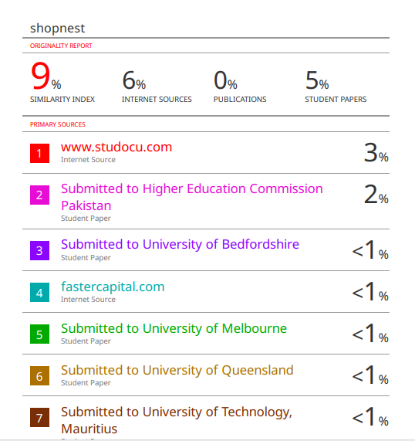

AI Detection Report

